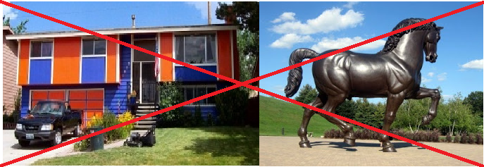

Join the ACC (Architectural Control Committee)
Have you ever had a friend or neighbor who wants to paint their house Orange and Blue or place a 10 foot tall bronze statue of a Horse in their front yard? Join the ACC and you can help avoid such a large mistake.
Foxwood Meadows is an incredibly aesthetically pleasing neighborhood which keeps home values high and a sense of community strong. This committee is an extremely vital part of our neighborhood. It will lead to more people thinking that “This is by far the best looking neighborhood we have seen” – Jody Jasmer
Please contact the HOA president if you are interested in joining the ACC.
www.foxwoodmeadows.com

